**QUEUE FOR NEXT DAY – TOOL GUIDE**

**Find the steps to use the tool:**

**1. Windows users: *Page no. 2-4*; 2. MAC users: *Page no. 5-7***

**Pre-requisites:**

1. Make sure that everything written between the > sign should be either completely bold or completely non-bold. Putting any number of spaces won’t affect the parsing of the queue.
2. If a person is on leave or is BM, then only mention that inside a bracket (). The tool works in the following way: *If the tool finds an opening bracket ‘(‘then it will check if BM is mentioned inside that bracket or not. If not, then the tool considers that person on leave and will apply left-right rule on them.*

|  |  |  |
| --- | --- | --- |
| **Queue** |  | **Reason** |
| **Aafreen** > **Abhay** > **Abhinav3** > **Abhishek** > Amarnath(PTO) | Checkmark with solid fill | Abhinav and 3 both are written in bold (Space between the name and the number or bracket doesn’t matter).  Amarnath and (PTO) are completely written in non-bold. |
| Aafreen > **Abhay** (SL) > **Abhinav5** > Abhishek > Amarnath | Close with solid fill | Abhinav and 5 both are written in bold. Space between them doesn’t matter but this is incorrect since Abhay is in bold and (SL) is non-bold. So, un-bold Abhay as well. |
| Aafreen > Abhay > Abhinav **-1** > Abhishek > Amarnath | Close with solid fill | Abhinav is non-bold while -1 is in bold. Make the -1 as non-bold. |
| Aafreen > Abhay > **Abhinav** 5 > Abhishek > Amarnath | Close with solid fill | Abhinav is in bold while 5 is in non-bold.  Write the number 5 in bold as well. |
| Aafreen > Abhay -1 > Abhinav> Abhishek (BM) > Amarnath | Checkmark with solid fill | Abhay and -1 are both in non-bold. |
| Aafreen > Abhay -1 > **Abhinav3** > Abhishek > Amarnath | Checkmark with solid fill | Abhay and -1 are both in non-bold and Abhinav and 3 are both in bold (Space doesn’t matter). |
| Aafreen > Abhay -1 > **Abhinav (Off-queue)** > Abhishek > Amarnath | Exclamation mark with solid fill | Abhay and -1 are both written as non-bold.  Abhinav is considered on leave as BM word is not written inside the bracket, left-right will be applied and he will be marked as -1. |
| **Aafreen** > Abhay 1 (internet issue) > Abhinav> Abhishek > Amarnath | Exclamation mark with solid fill | If Abhay has picked 1 case and rest have picked more and Abhay is not to be considered on leave so remove the (internet issue) otherwise Abhay will be considered on leave by the tool. |
| **Aafreen** > Abhay (internet issue) > Abhinav> Abhishek > Amarnath | Exclamation mark with solid fill | If Abhay has not picked any case and is going to be marked on leave then we can still leave the (internet issue). |

**Follow the below steps to make the Queue for next day:**

**FOR WINDOWS USERS:**

**Step 1**: Make sure that it is in the correct format as mentioned in the Prerequisite section above. Let say the last queue for the present-day is as follows:

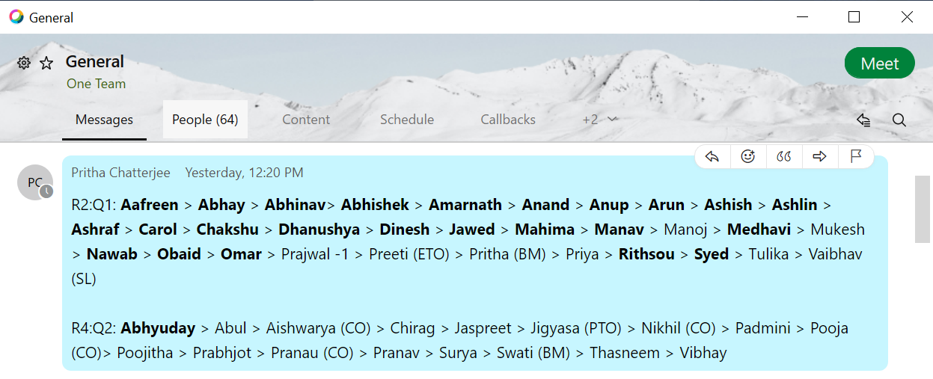

**Step 2:** Copy the queue of Q1 starting from the first name till the last name and paste it in a word document so that the bold name retains their bold property.

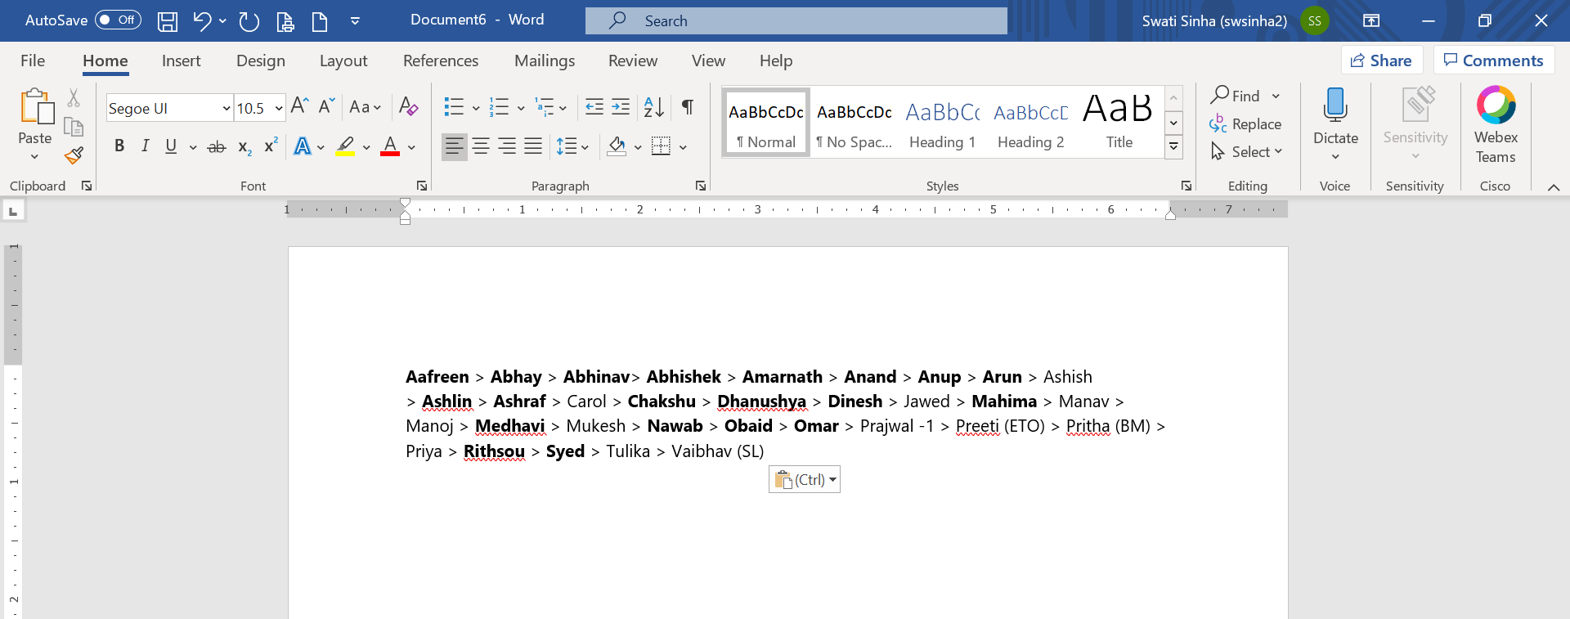

**Step 3:** Now copy the same from the word document and paste it in a WordPad file. It is important to use WordPad as Word Document adds some encoding because of which it parses the queue in an incorrect way.

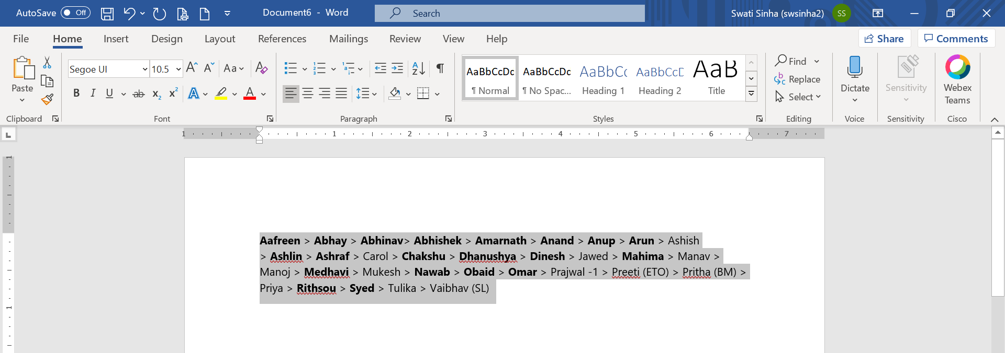

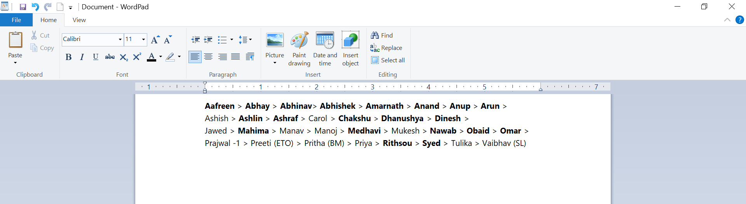

**Step 4:** Now save the file in Office Open XML document format by giving a file name.

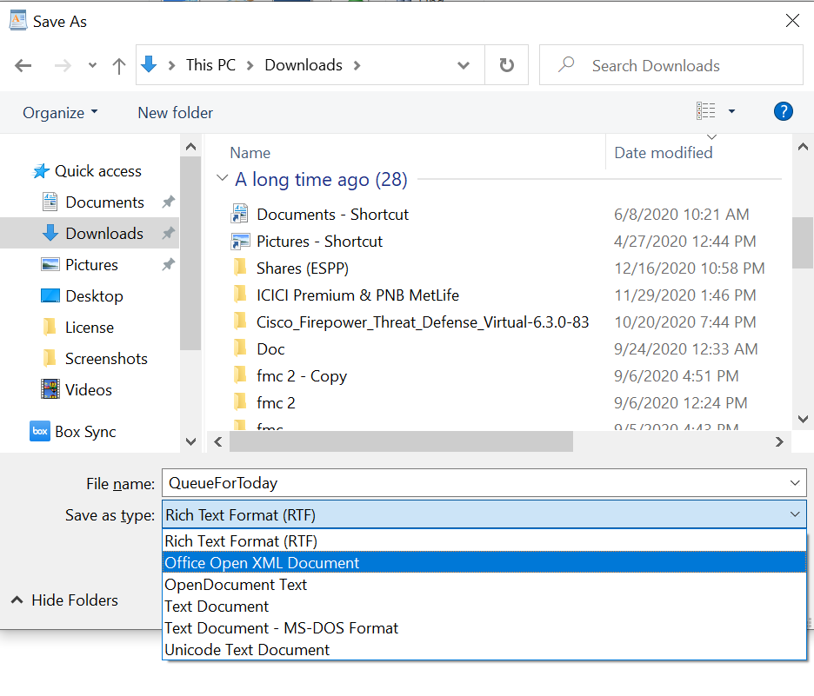

Make sure to save the file with Office Open XML Document format.

**Step 5:** Now open the following link: <https://queue-for-next-day.herokuapp.com/next_day_queue>

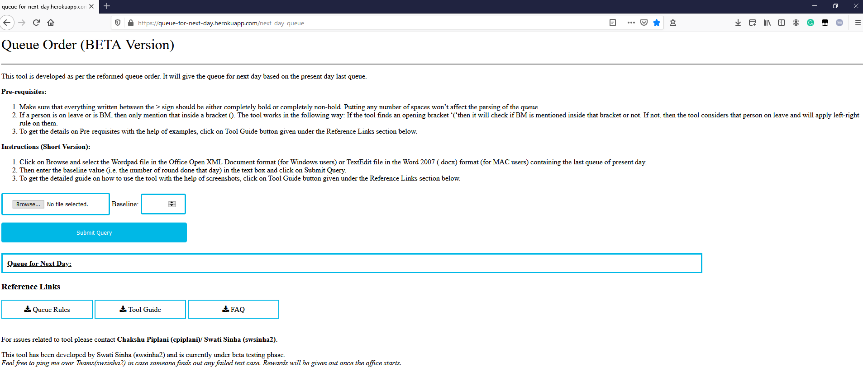

**Step 6:** Browse and select the WordPad document which we saved in Step 4. Enter the baseline value, which is the number of rounds completed that day, like in the above example it is 3 (as R3 was going on) and then finally click on Submit Query.

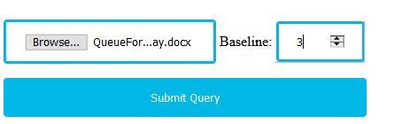

**Step 7:** Voila! You can see the Queue for Next Day in the text box below the button. It can be copied from the webpage directly to the WebEx Teams, it will retain the bold and non-bold property.

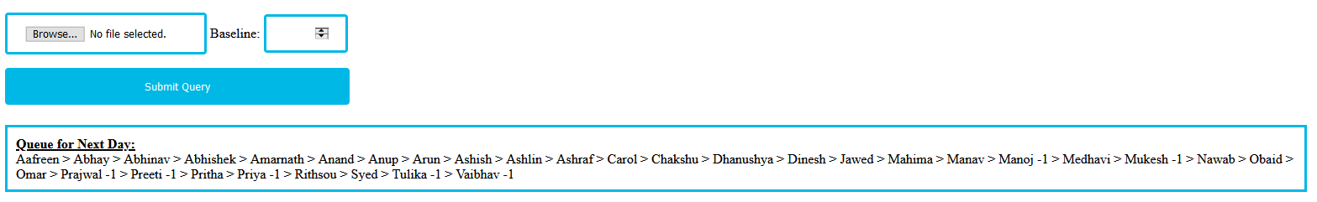

**Step 8:** Copy Q2 and follow all the steps from 2 to 6 to get the Queue for next day for Q2.

**FOR MAC USERS:**

**Step 1**: Make sure that it is in the correct format as mentioned in the Prerequisite section above. Let say the last queue for the present-day is as follows:



**Step 2:** Copy the queue of Q1 starting from the first name till the last name and paste it in TextEdit file.

**Step 3:** Now save the file in Word 2007 (.docx) format by giving a file name.

Make sure to save the file with the following file format.

**Step 5:** Now open the following link: <https://queue-for-next-day.herokuapp.com/next_day_queue>



**Step 6:** Browse and select the TextEdit document which we saved in Step 3. Enter the baseline value, which is the number of rounds completed that day, like in the above example it is 3 (as R3 was going on) and then finally click on Submit Query.

**Step 7:** Voila! You can see the Queue for Next Day in the text box below the button. It can be copied from the webpage directly to the WebEx Teams, it will retain the bold and non-bold property.



**Step 8:** Copy Q2 and follow all the steps from 2 to 6 to get the Queue for next day for Q2.